**Objective**: In this lab you will be testing a few sensors and gadgets with Raspberry Pi and learn about database.

**Required Setup**: Connect GrovePi+ board to RPi and have all GrovePi+ libraries installed.

**Deliverable:** Show me your sensor working properly and LCD screen is showing correct information.

**Parts:**

* RPi 3 B
* GrovePi+ board
* Two Grove connection wires
* 1 x Grove Temperature and Humidity Sensor
* 1 x Grove LCD RGB Backlight v4.0
* 1 x Grove Sound Sensor

**Part A: Sensors and gadgets**

**Step 1.** Power on the Raspberry Pi, and open a terminal (The directions are the same when using the terminal on a standard Raspberry Pi with a monitor or SSH).

**Step 2.** Change directories to the Desktop. Clone the GrovePi git repository by using the command below:



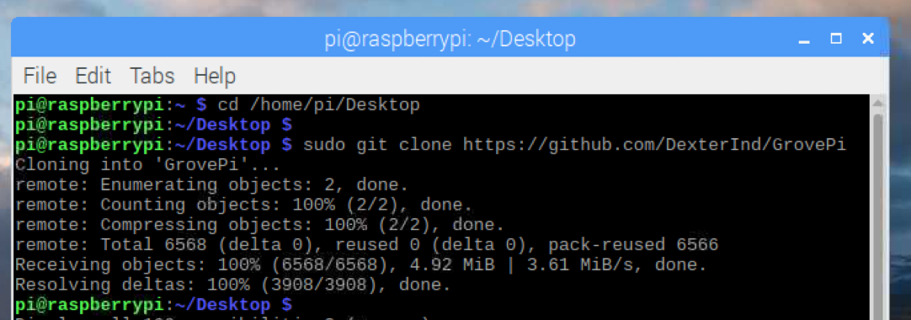

When We’re done downloading, you should find a new folder on the desktop called “GrovePi”

**Step 3.** Go to the scripts folder in the GrovePi folder.





**Step 4.** Make the install.sh bash script executable. Use following command to modify the permissions of the script and we can see install.sh turned to green by running the next command. This means it can be executed now.

****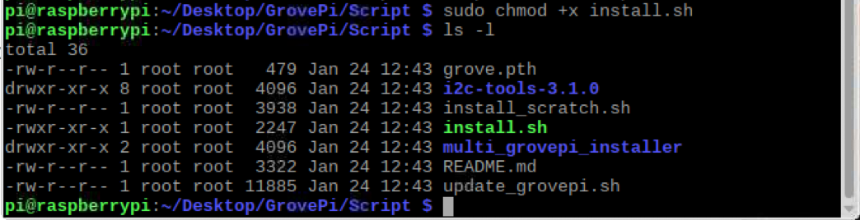

**Step 5.** Run the script and make sure you include “sudo” because you must be a root user. Then, press “enter”.



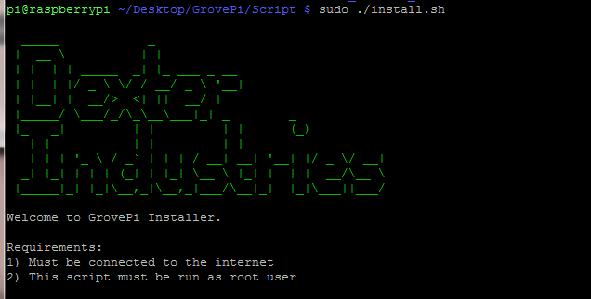

**Step 6.** The script will download packages which are used by the GrovePi+. Press “y” when the terminal prompts and asks for permission to start the download. Press “y” when the program pauses and anything prompts.

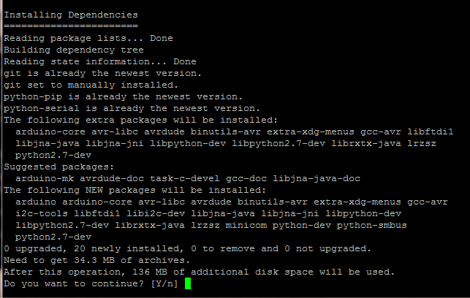

**Step 7.** The Raspberry Pi will automatically restart when the installation is complete. You must reboot the Raspberry Pi to allow the installation to take effect. Now, we are going to attach the GrovePi. Shut down you Raspberry Pi if it’s running and unplug the power cable for safety. In your Kit, find the blue GrovePi and install it on the top of the Raspberry Pi and matching up the pins, like the picture below.

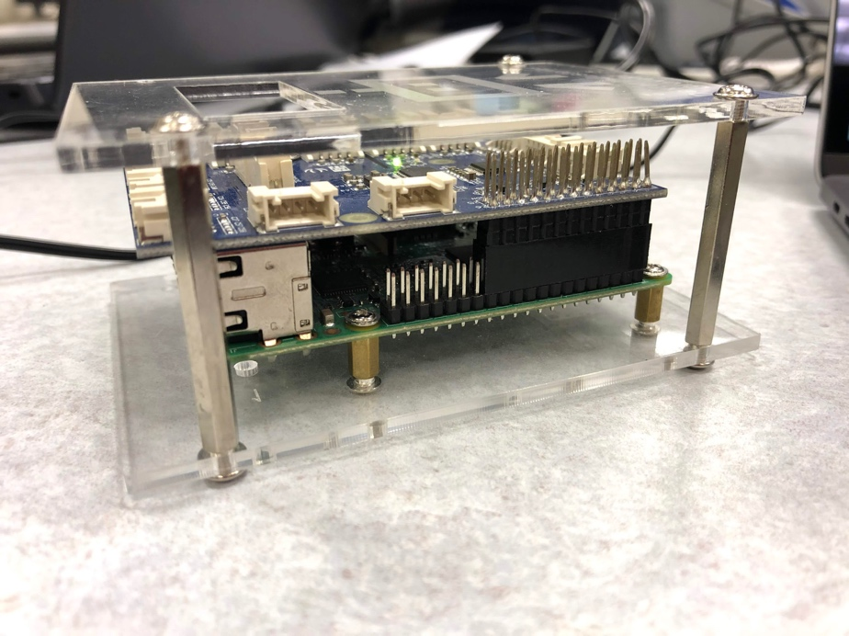

**Step 8.** Power on the Raspberry Pi. You will notice a green light on the GrovePi. After boot up, we can test whether the software for the GrovePi is installed correctly. Open a terminal and run the follow command.



If you have a Raspberry Pi sold before October 2012, run this command:





You should get the output in the above image. This means the Raspberry Pi is connected to the GrovePi.

**Step 9.** Now we are going to play around with the sensors. In your CanaKit, Find Gove Temperature & Humidity Sensor and Grove-LCD RGB Backlight v4.0. They should be the gadgets shown in the image below.

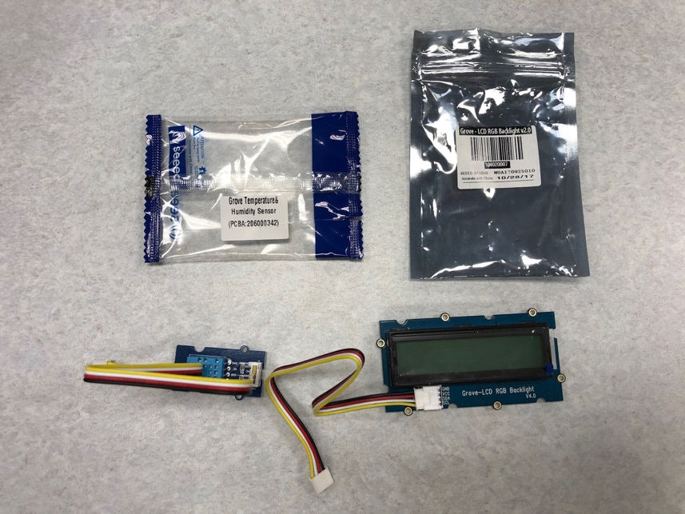

**Step 8.** Connect the DHT sensor to Port D7 on the GrovePi and the RGB LCD display to any of the I2C ports. Change Directory to Projects/Home_Weather_Display in the GrovePi folder. Run the script in the folder.



**Step 9.** You should get something like follow image after you run the script. The LCD screen should show the current temperature and humidity as well. Free feel to terminate it using “ctrl + c” anytime.

****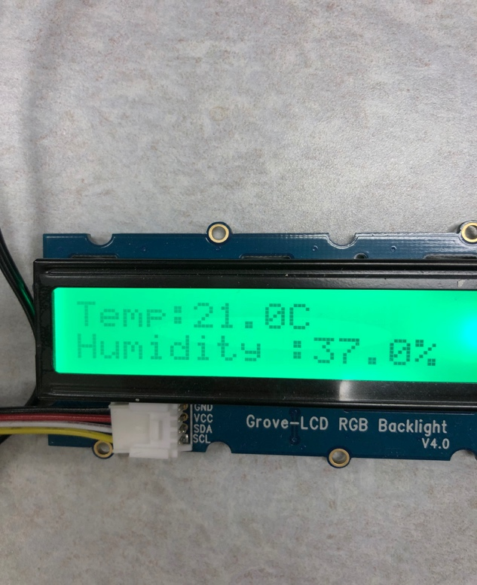

**Step 10.** Congratulations! You just made a temperature and Humidity monitoring device using Raspberry Pi.

|  |
| --- |
|  |

**Step 11.** Now it’s your chance to utilize a sensor on you own. Find Grove sound sensor from the kit and get another wire. Click on the “File manager” on the menu.. Follow this path “/home/pi/Desktop/GrovePi/Projects/Home_Weather_Display” to direct into the Home_Weather_Display folder. Double click on the .py file. The file should be opened using Thonny by default.



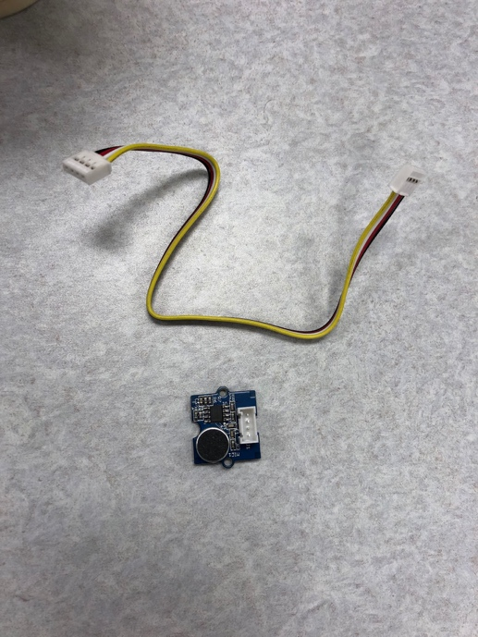**Step 12.** Study the code by yourself. It should contain enough comments for you to understand it. Try to connect the sound sensor to the GrovePi and write some extra code to get it working. For additional practice, you should also use the LCD screen to display sound level along with temperature and humidity. Here is an example of the LCD screen.

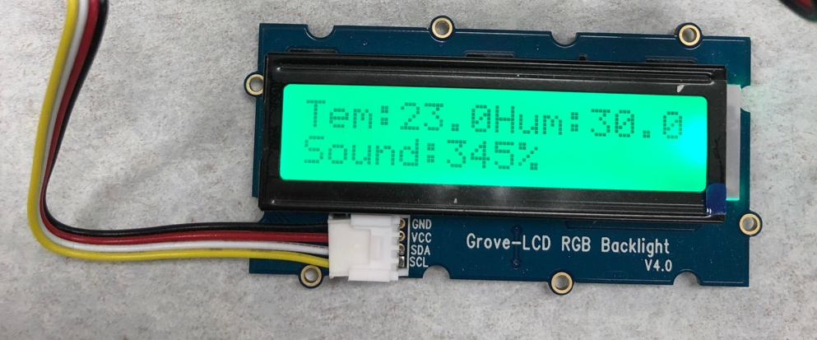

**Part B. Introduce database and MySQL**

Now, we have the sensors connected to our raspberry pi and they are generating data. It might be interesting if we did some analysis with those data. We will start with building a **database**. A database is a collection of related data which is known facts. It’s being daily used by a lot of companies and basically everywhere. A database management system(**DBMS**) gives users the functionality for adding, modifying and querying that data. Different kinds of databases store data in many different ways and what we are going to use here is called relational database, which store data in tabular form and it’s currently the most common in the industry. One of the many popular DBMS in the industries is MySQL and we will be using MySQL for our database as well. The programming language which MySQL is using is Structured Query Language(SQL). Don’t be panic. Even though you do not know how to program in SQL, we will teach you step by step and SQL itself is not that hard to understand.

Since MySQL is such a popular database engine, it’s really easy to install it on raspberry Pi. Let’s install MySQL this week and it will be really helpful for the next week’s material.

**Step 1.** First, we need to install the MySQL server onto the Raspberry Pi. Open the terminal and run the following command. Type “Y” if anything prompts.



**Step 2.** Next, run the following command and you will be prompted to enter a password for the root user. Make sure you save the password because we will need that to access the MySQL server later on.



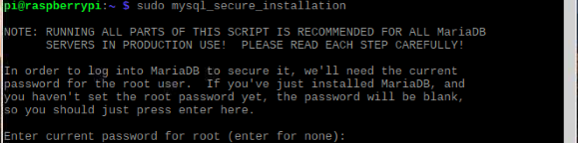

**Step 3.** Answer all the questions to set up the database properly. Follow the following screenshot.

The answers for all the questions will be: n y n y y. After that, the database set up is completed.



**Step 4.** Now type the following command and access the database.



**Step 5.** It will prompt to ask for password. After enter the password, you are not in the MySQL environment. To leave the MySQL, you can simply type quit.



Next week, we are going to learn more about MySQL commands and use it to collect data through the sensors.

Reference:

1. <https://www.dexterindustries.com/GrovePi/get-started-with-the-grovepi/setting-software/>

2. <http://download.microsoft.com/download/A/4/D/A4DAD253-BC21-41D3-B9D9-87D2AE6F0719/Microsoft_Azure_IoT_Reference_Architecture.pdf>

3. <https://www.coursera.org/learn/sql-data-science>

4. <https://pimylifeup.com/raspberry-pi-mysql-phpmyadmin/>